
Invest Punjab Fasttrack Punjab Portal

Grant of License Under Contract Labour (R and A) Act-1970 (Fresh)

Department of Labour Govt. of Punjab

User Manual

Invest Punjab Business First
Designed and developed by NIC Punjab



About:
Grant of License Under Contract Labour (R and A) Act-1970 (Fresh)

Types of Application: Statutory
Stage: Pre-construction

- Open https://fasttrack.punjab.gov.in/webportal/login in your web browser, it will open login screen as shown below:
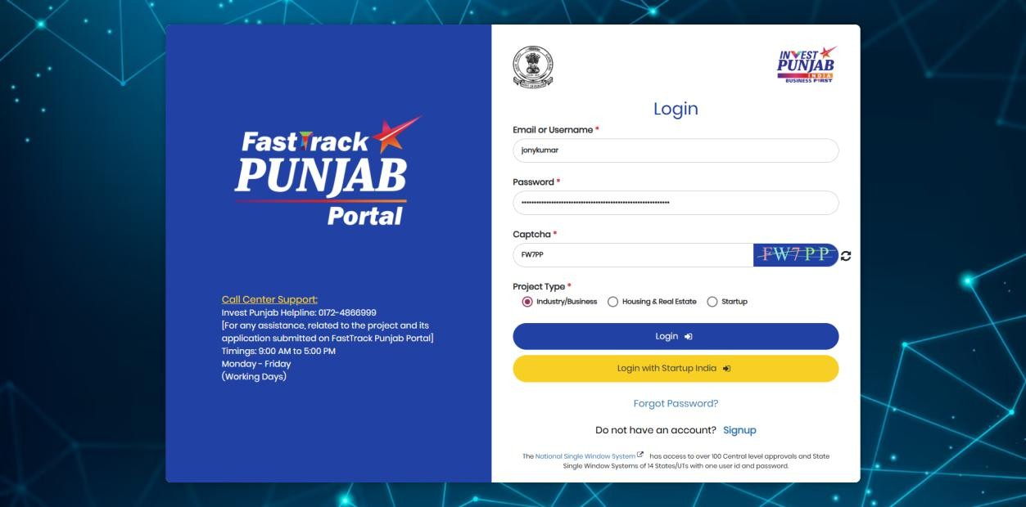
Enter Username,
Password & Captcha code

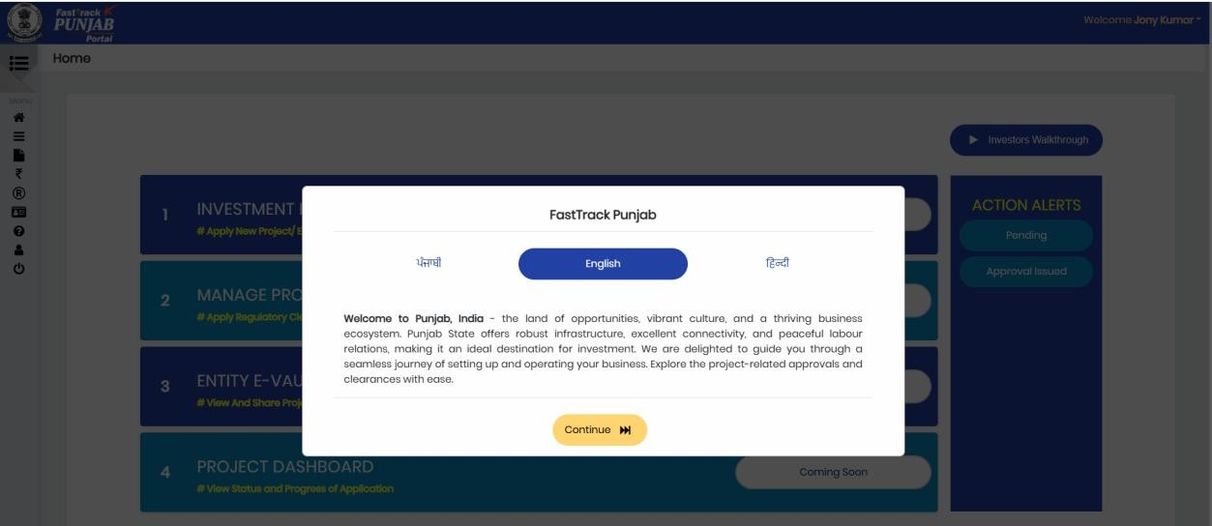
- Investor will click on Continue button as shown in below screen:
Click to Continue

- After clicking on Continue button investor will click on My Projects as shown below:
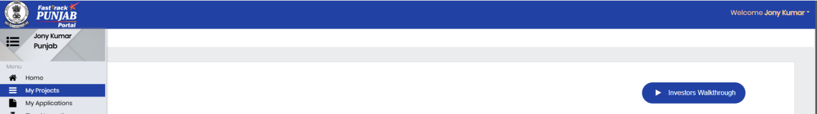

Click on My Projects button

- For having Service Clearance, investor needs to fill Service Common Application Form i.e. S-CAF. SCAF auto verified by the system.
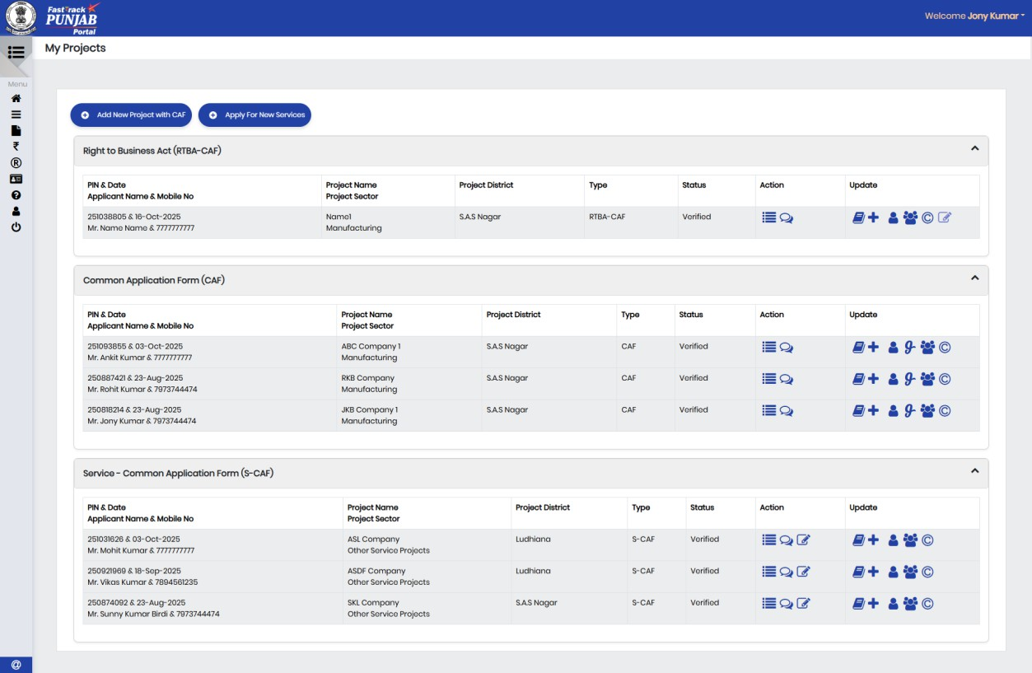

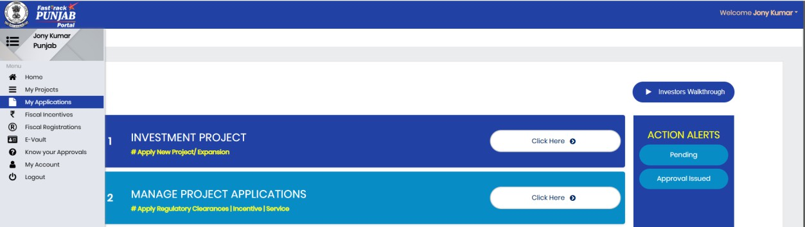
- Investor will click on Manage Project Applications as shown below:
Click to Continue

- Once S-CAF verified, the Investor needs to go to project details page by clicking Details button on the screen as shown below:
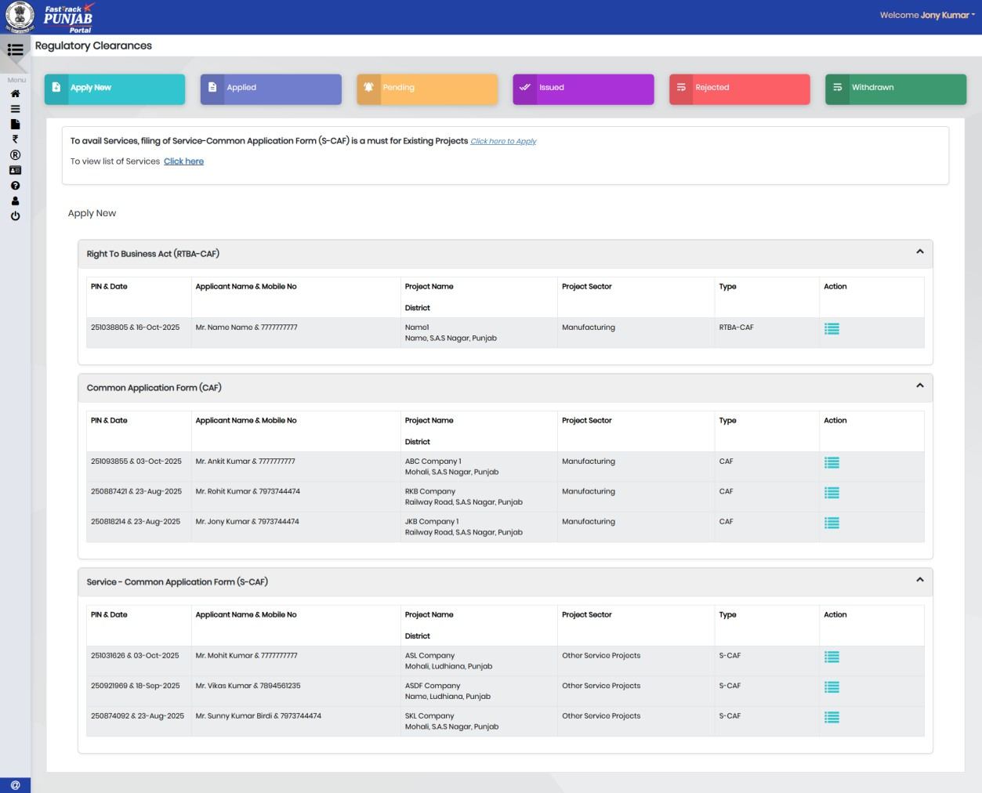
Click to Continue

- Following screen will appear, click on Apply for New Clearance button:
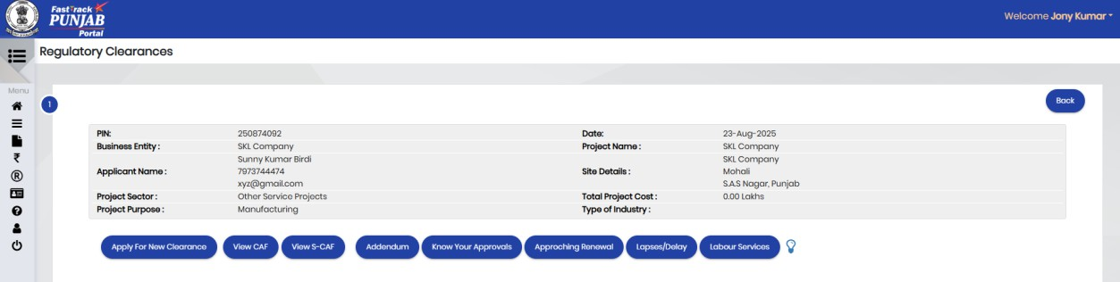
Click to Continue

- Search the Application Form by giving Department Name or Application Name on the screen as shown below:
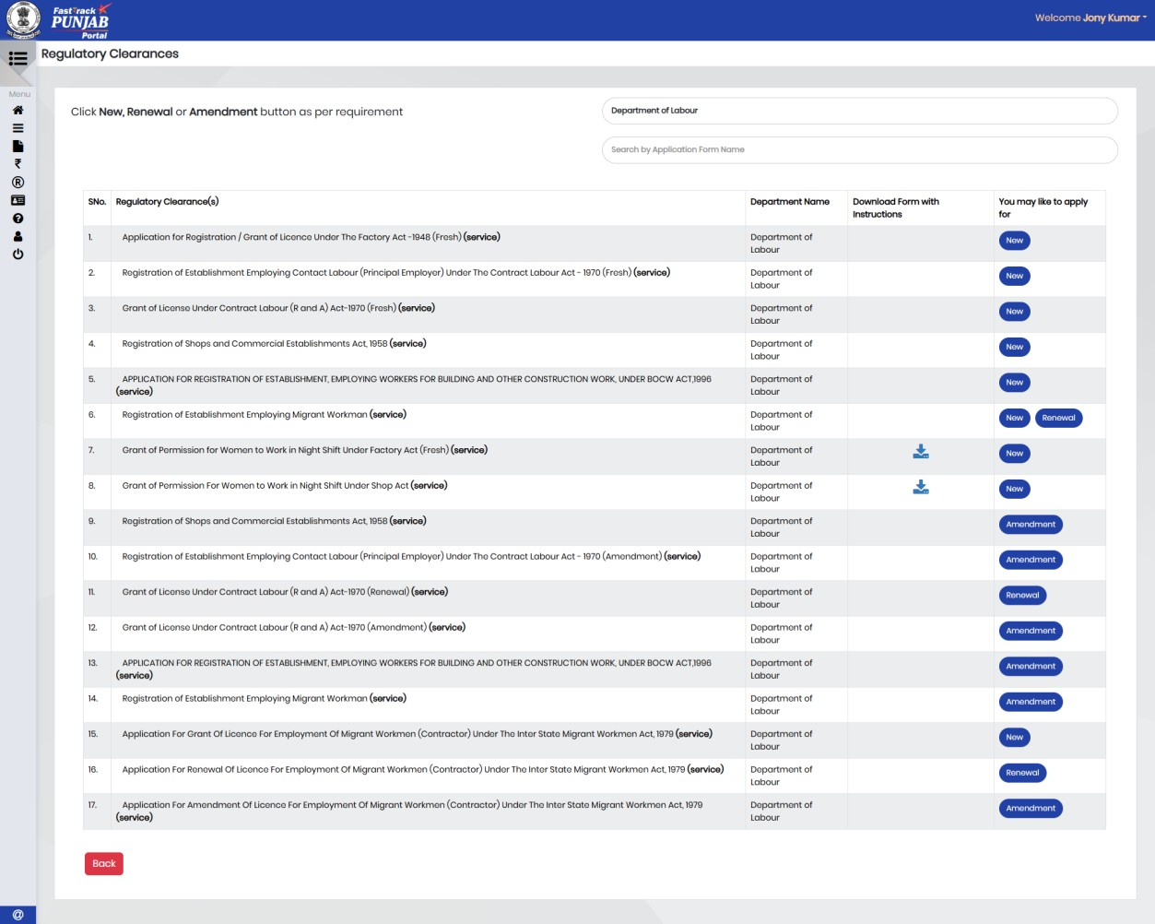
Click on New button
Click New button in front of Application Name on the screen as shown above.
- Investor will select the portal from which they are availing the service as shown below:
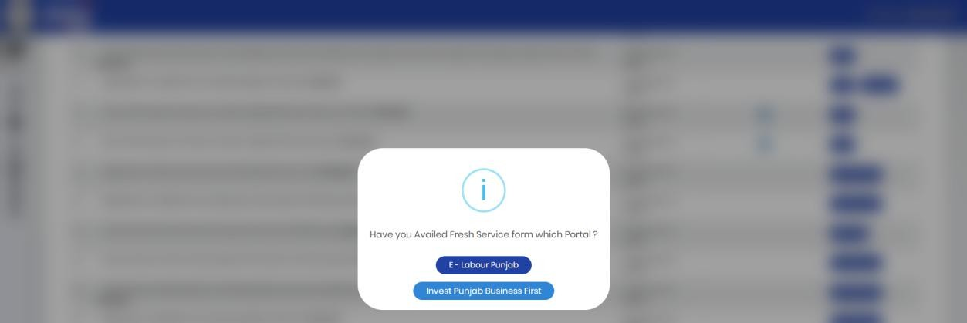
Investor will select the portal

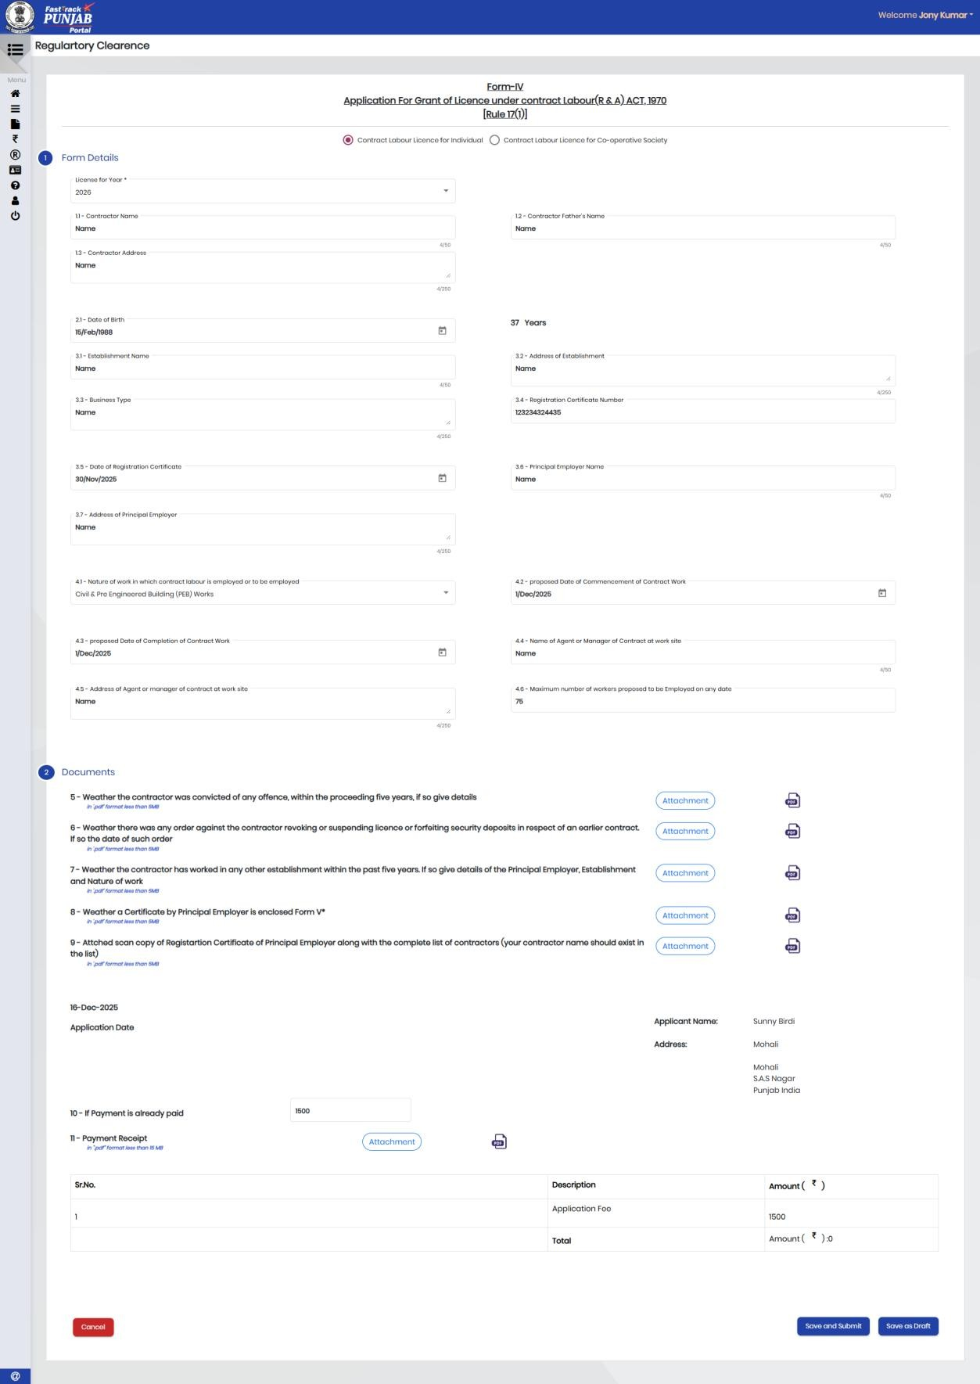
- Application Form will appear; Investor will fill Application Form on the screen as shown below:

Click on Save and Submit button

- The system will confirm form submission with following message:
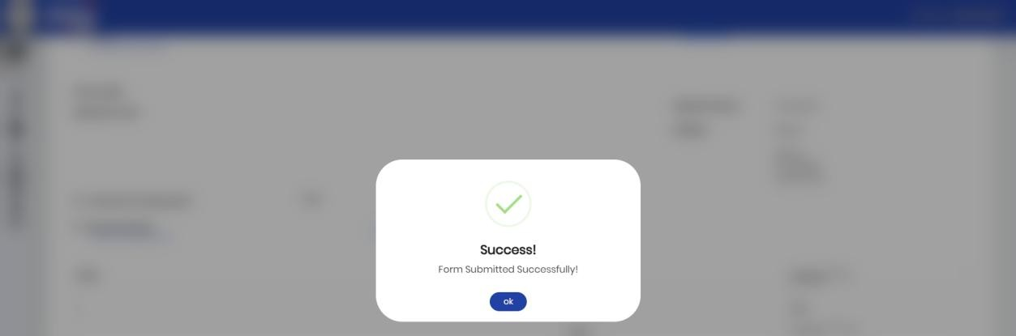
Click on Ok button

- Once applied by investor, the application will move to Under Pre-Scrutiny radio button under Pending folder of Dealing Hand dashboard as shown below:
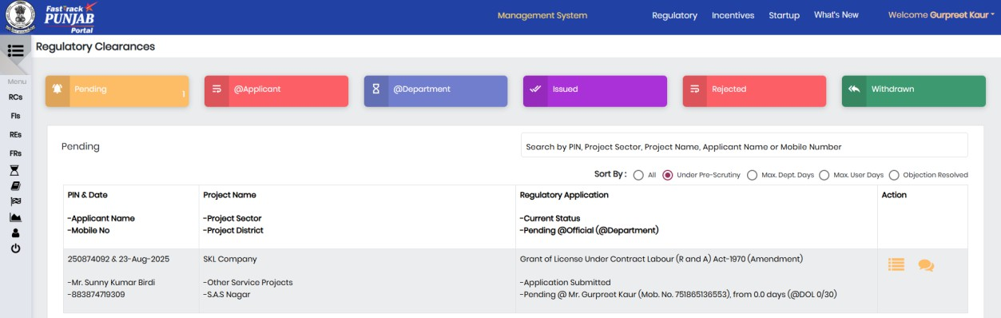
Click to Project
Details
Dealing Hand needs to click Details button in front of Application as shown above:
- For processing, Dealing Hand needs to click Process button on the screen as shown below:
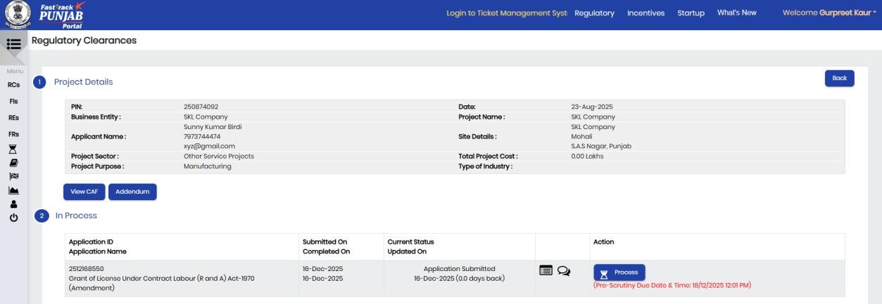
Click to View Form
Click to View Logs
Click to Process
Please note that system is showing Scrutiny Due Date & Time. _{Scrutiny} _{Due} _{Date} &

- Dealing Hand can check the View Form and Logs also:
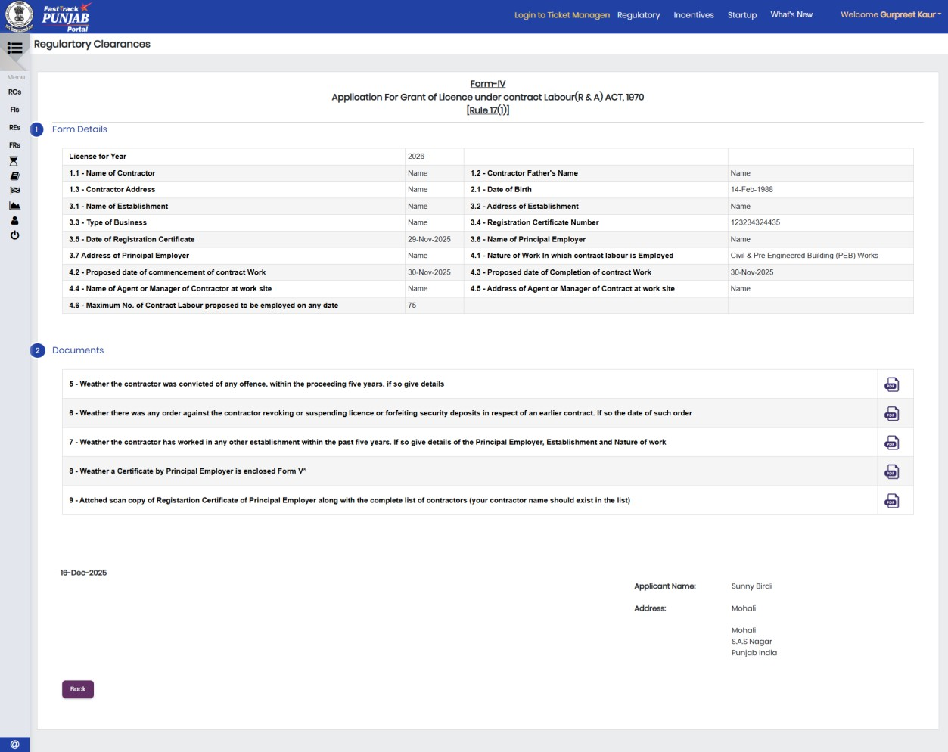
- View Logs as shown below:
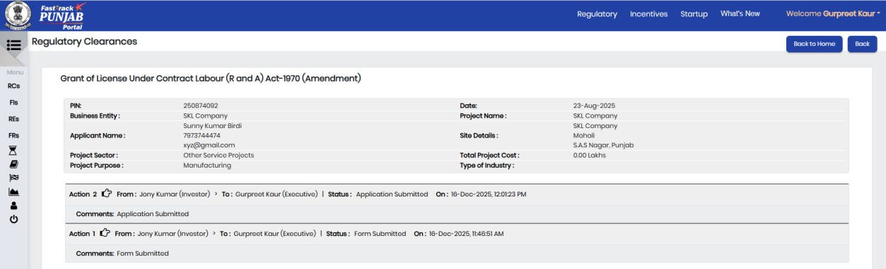

- For Process the application Dealing Hand will have to Click on Process button as shown below:
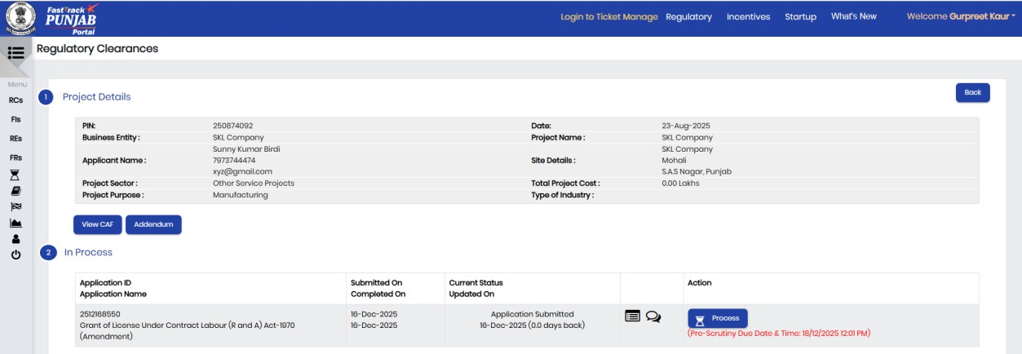
Click Process

- Once Process clicked, the system will ask for following declaration:
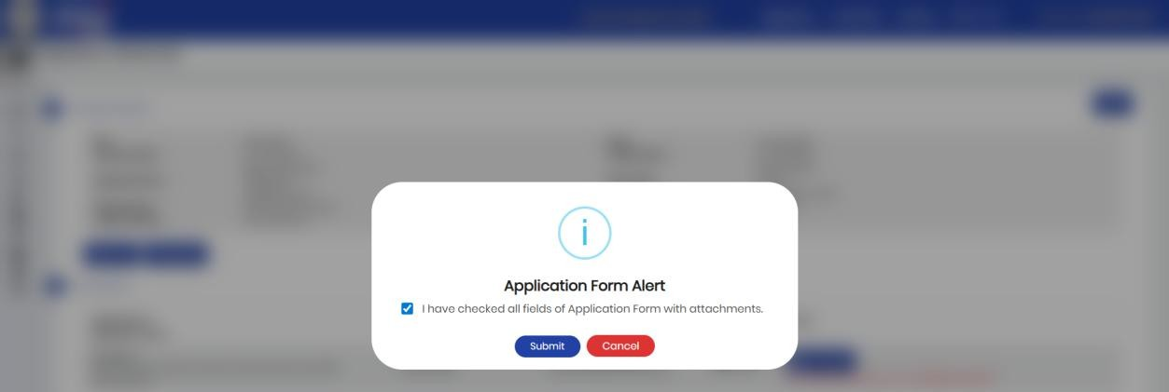
Click On Submit

- For processing, Dealing Hand will have 01 options (Forward to Supervisor/Nodal Officer) as shown below:
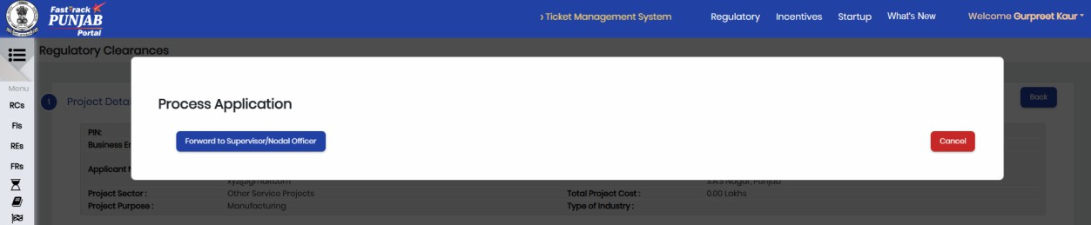

Click Forward to Supervisor/Nodal Officer

- Here Dealing Hand forward the application to Nodal Officer. Following screen will appear where Dealing Hand can give his/her comments:
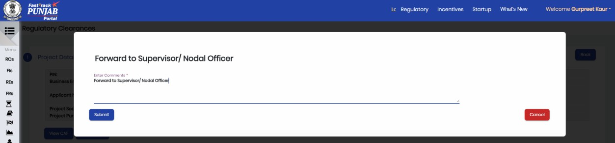
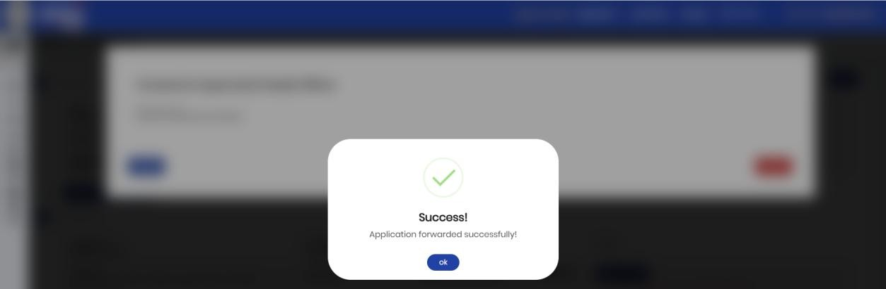

Click on Submit after enter the comment.
Click OK

- The application will move to Nodal Officer dashboard, the screen will look like as shown below:
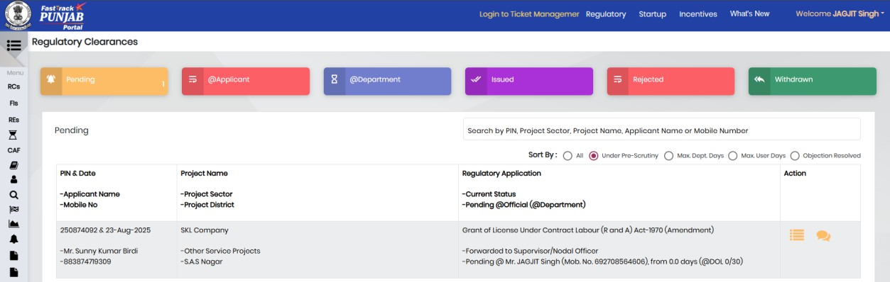
Click to Project
Details

- For processing, Nodal Officer needs to click Process button on the screen as shown below:
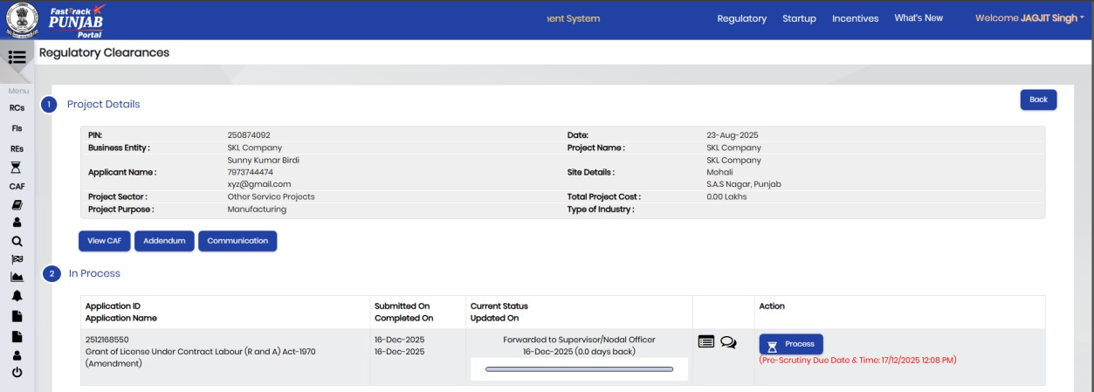
Click Process button

- Once Process clicked, the system will ask for following declaration:
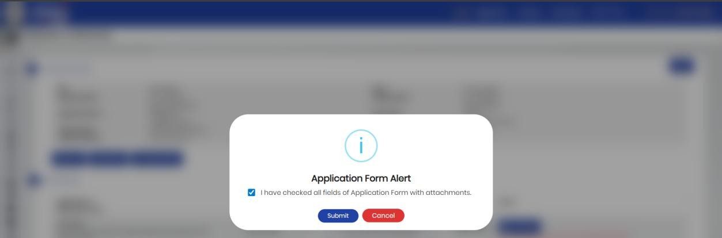
Click on Submit button

- For processing, Nodal Officer will have 3 options (Raise Pre- Scrutiny/Complete Pre-Scrutiny/Incomplete Application) as shown below:
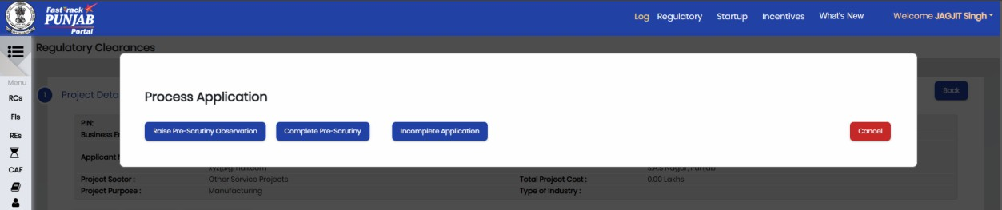

Click Here to Raise Pre Scrutiny Observations

- Here Nodal Officer is raising observation by clicking Raise Pre-Scrutiny Observation button on the screen shown below. Following screen will appear where Nodal Officer can give his/her comments:
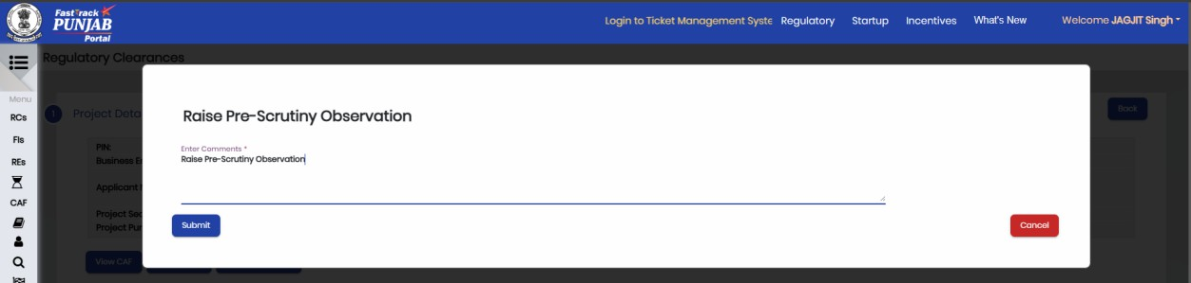

Click on Submit after enter the comment.

- Once Pre-Scrutiny Observation raised the system will ask for following declaration:
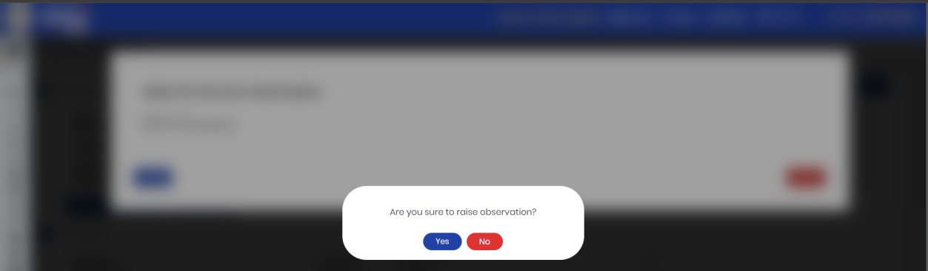
Click Here

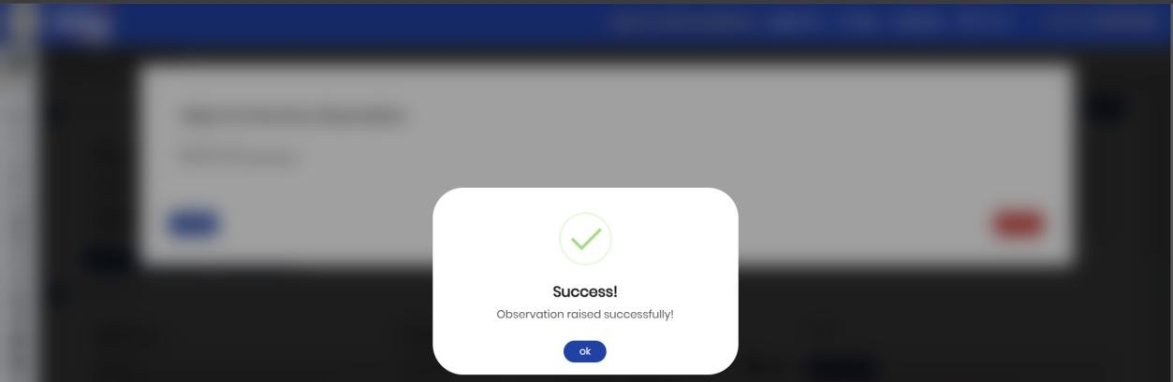
Click Here

- Once Observation raised by Nodal Officer, Application will go back to
Investor’s dashboard as shown below:
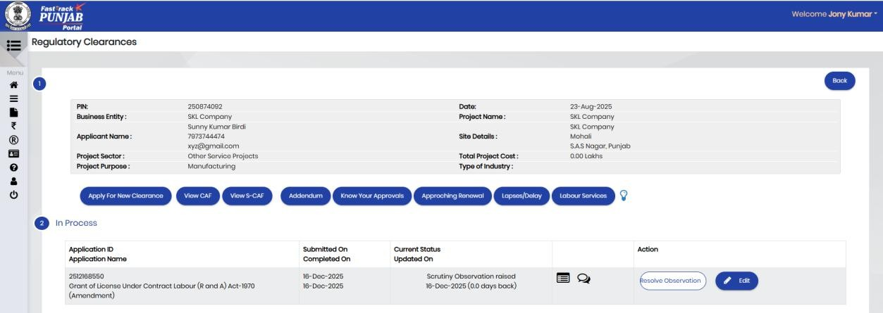
Click Here to Resolve Observation

- Investor can edit the Application Form and reply to Nodal Officer on the screen as shown below:

Click Here

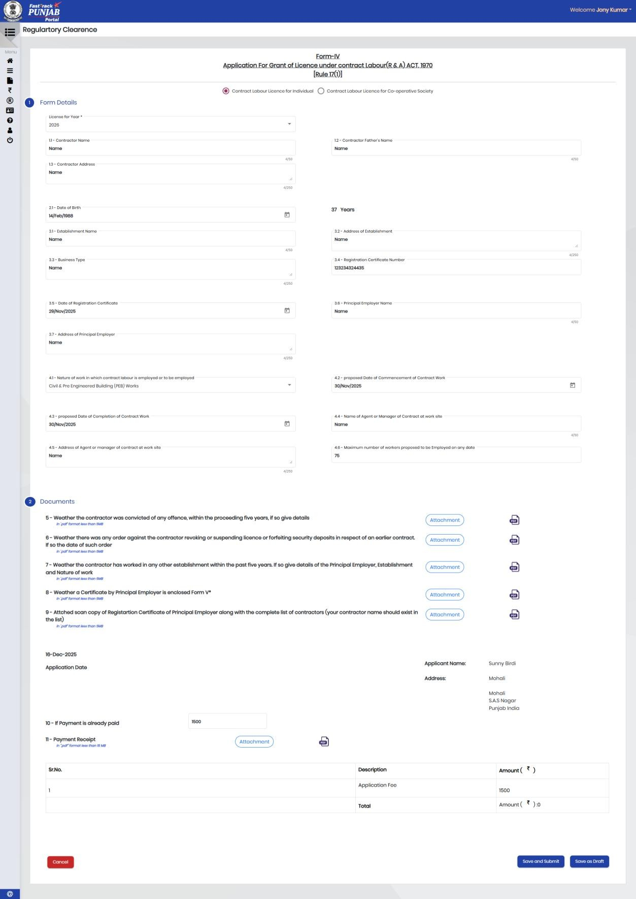
Click Here to save the form

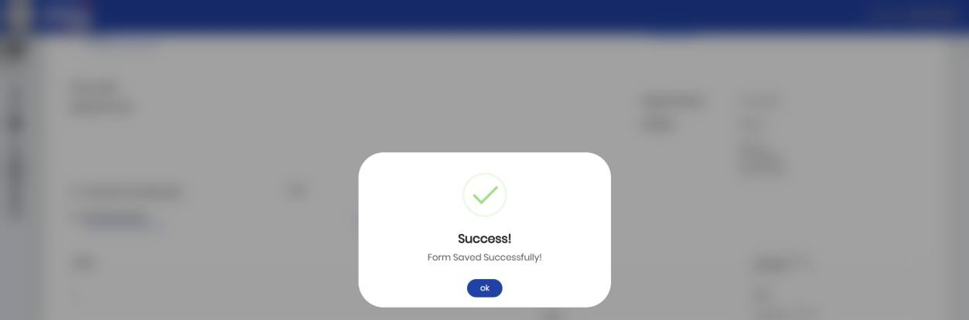
Click Ok to confirm

- After giving reply, the investor will click on Reply button on the screen as shown below:

Enter comment and click
on Reply button


Click on Ok button

- After observation resolved by Investor, the application will move to Nodal Officer Officer’s dashboard, the screen will look like as shown below:
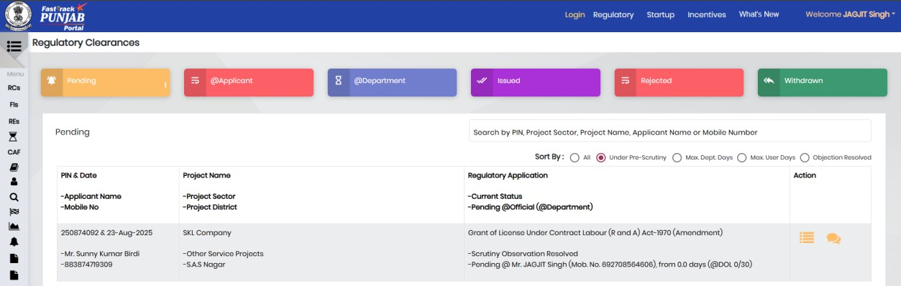
Click Here

- To Process the application Nodal Officer will click on Process button as shown below:
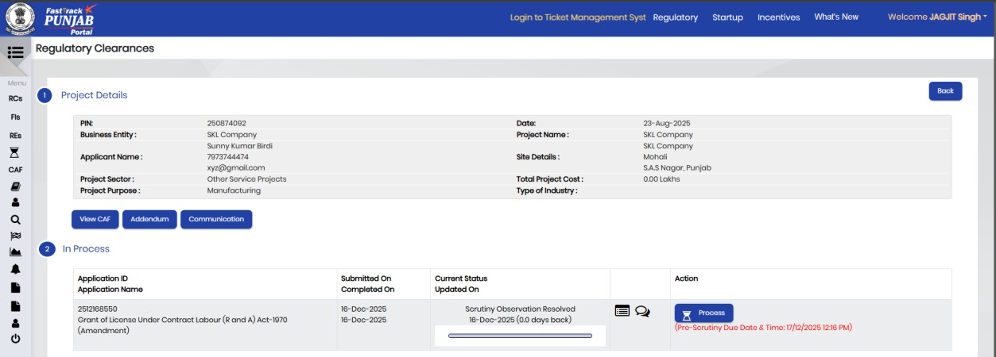
Click on Process

- Once Process clicked, the system will ask for following declaration:
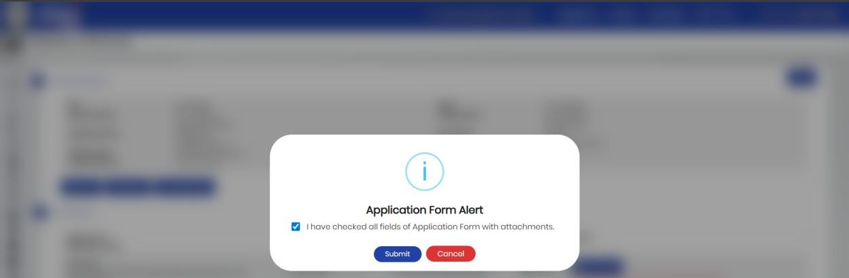
Click on Submit button

- Once investor has resolved the observation, the Nodal Officer will have 2 options (Complete Pre-Scrutiny /Incomplete Application). The page will look like as shown below:
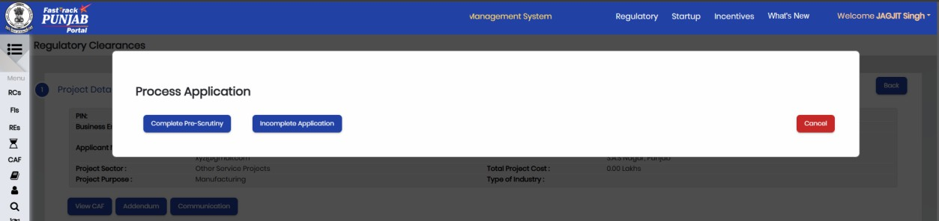
Click Here to Complete Pre-Scrutiny

- To complete the Pre-scrutiny, the Nodal Officer will click on the Complete Pre-Scrutiny button on the above screen. The Nodal Officer will also provide his/her comments in the section shown below:
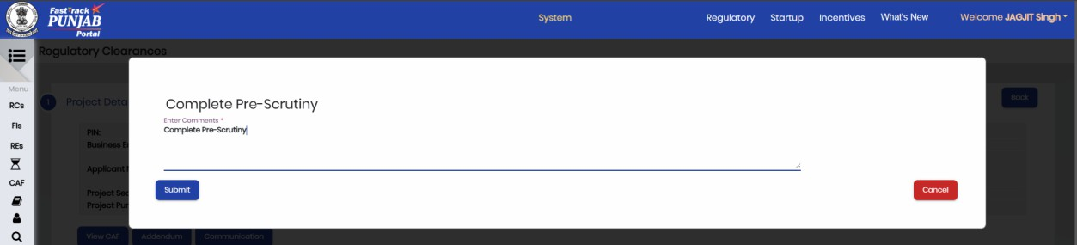
Click Here


Click Here
Pre- Scrutiny Completed by Nodal Officer as shown above:

- After Pre-Scrutiny Completed, the application will move to Dealing Hand
dashboard, the screen will look like as shown below:
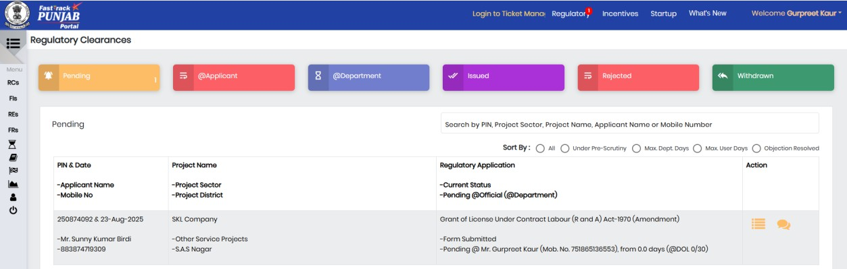
Click Here

- For processing of application, Dealing Hand needs to Click on Process button shown below:
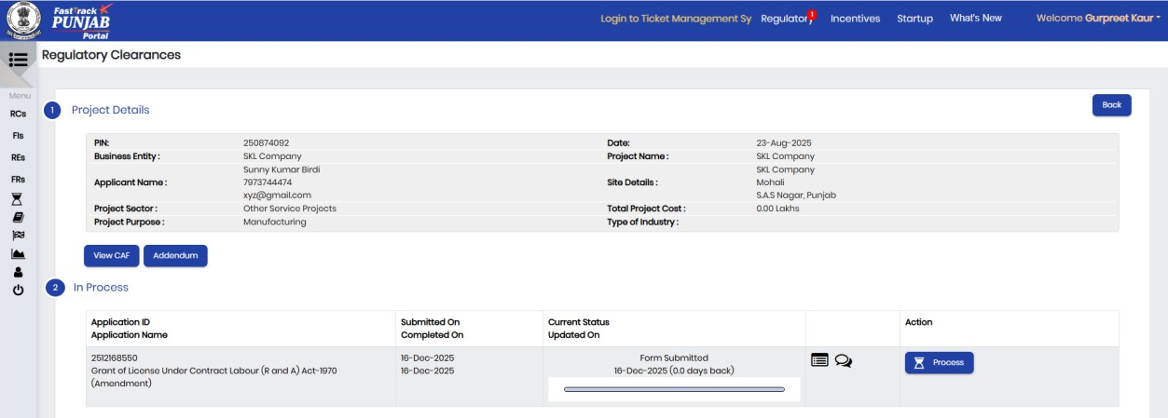
Click Here

- Here Dealing Hand is sending application to Nodal Officer as shown below:
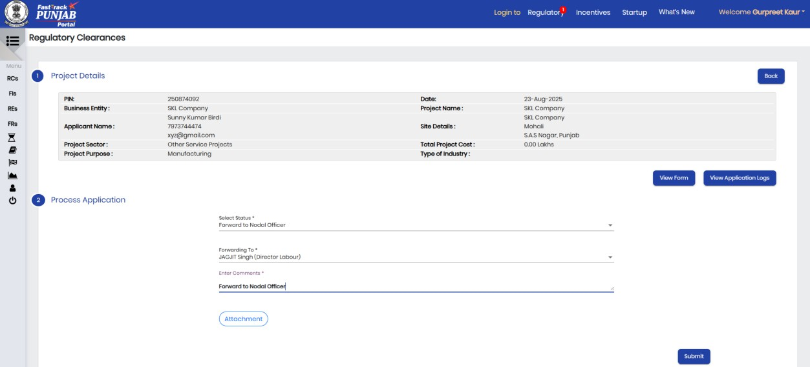
Click Here


Click YES button

- The application will move to Nodal Officer dashboard, the screen will look like as shown below:
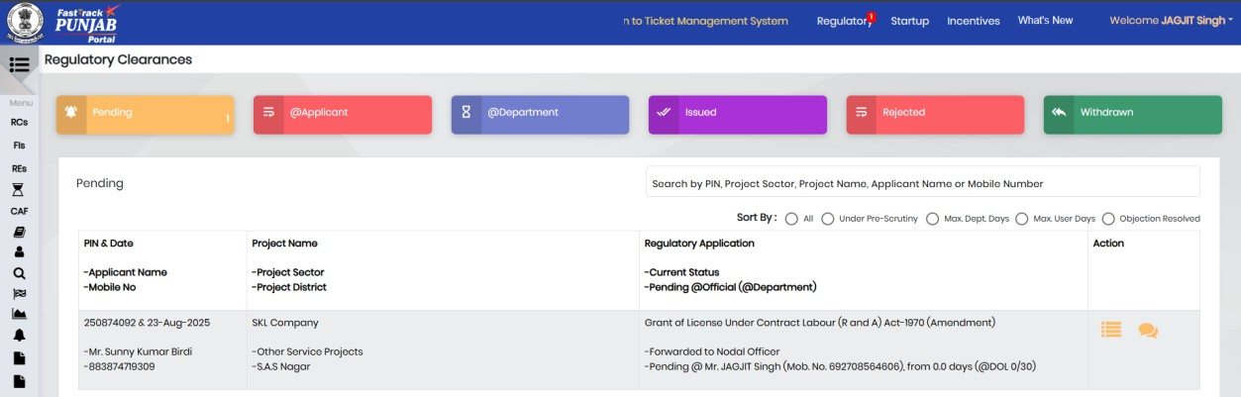
Click Here

- For processing of application, Nodal Officer needs to Click on Process button shown below:
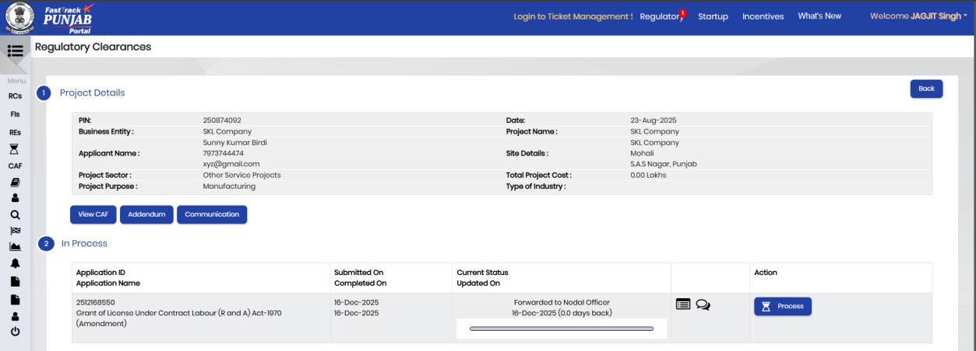
Click on Process button

- Here Nodal Officer is sending application to HOD as shown below:
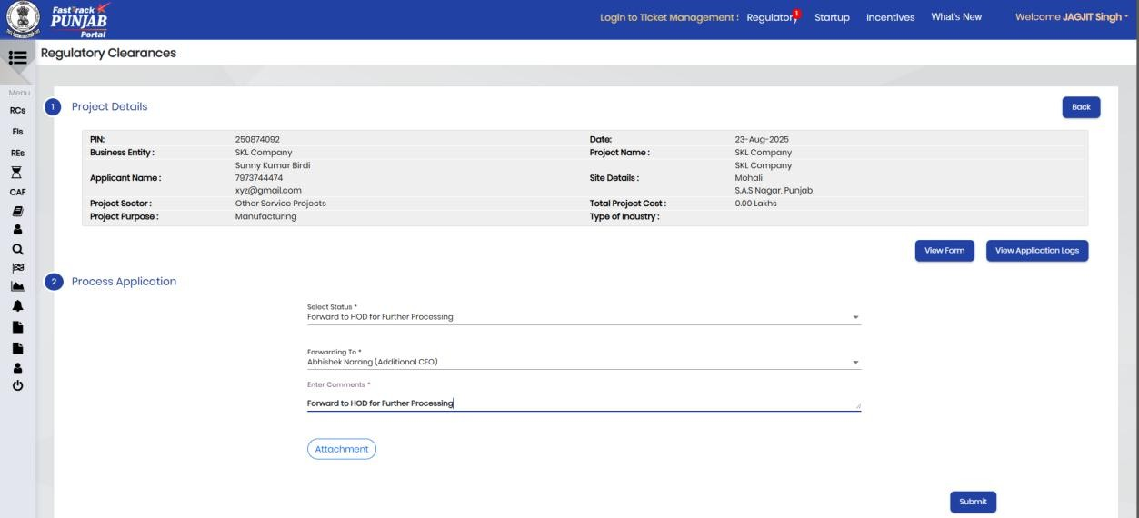
Click on Submit button

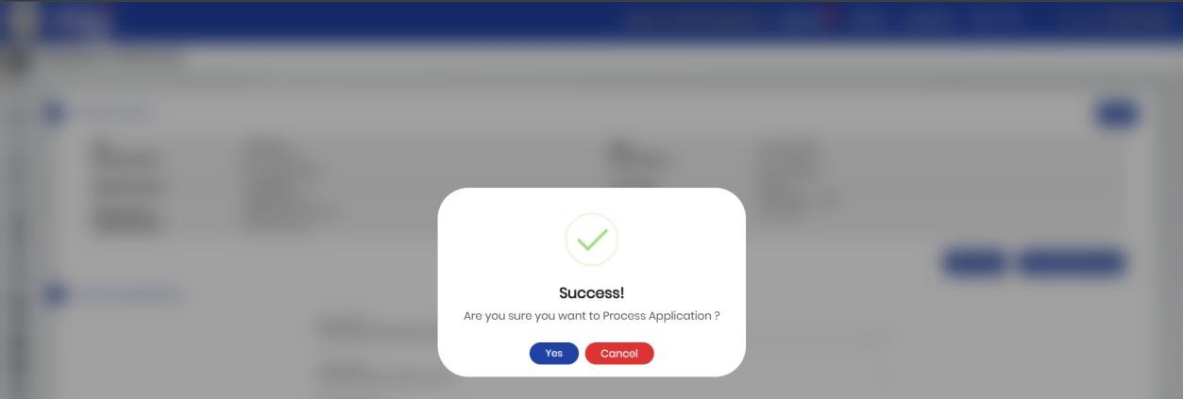
Click Here

- The application will move to ACEO dashboard, the screen will look like as shown below:
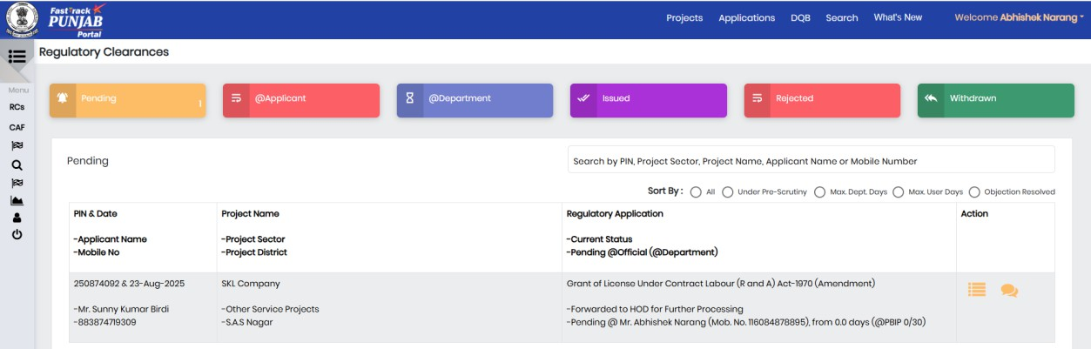
Click Here

- For processing of application, ACEO needs to Click on Process button shown below:
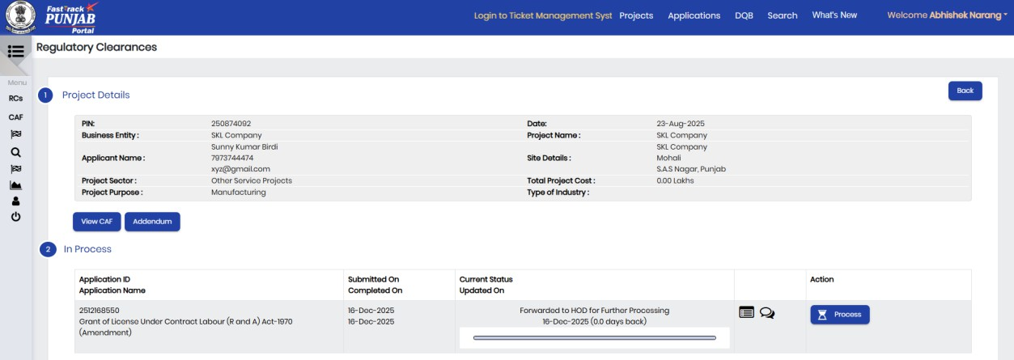
Click on Process button
- For processing, ACEO will have following options:
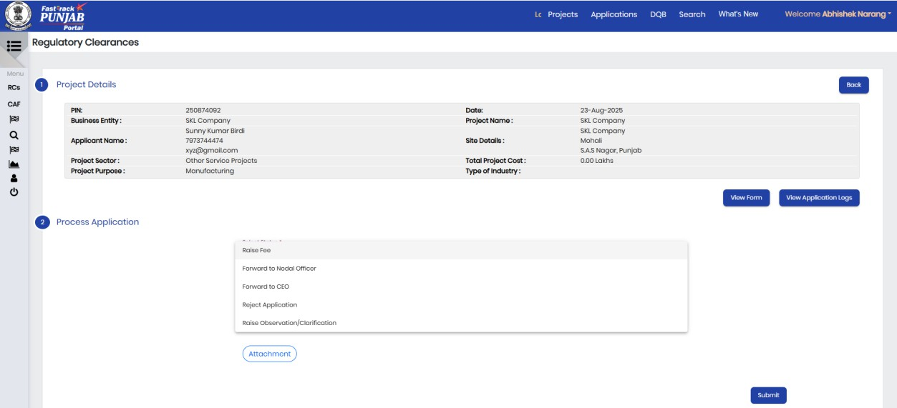
Click Here
- Here ACEO is sending application to CEO as shown below:
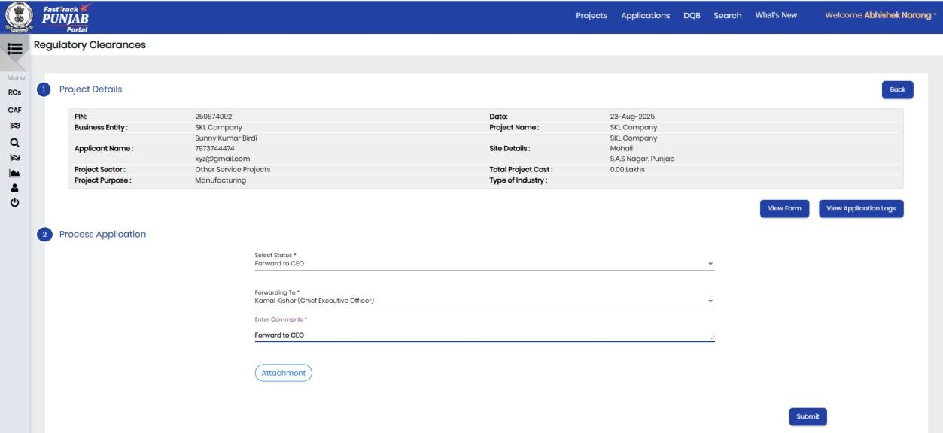
Click Here


Click Here

- The application will move to CEO dashboard, the screen will look like as shown below:
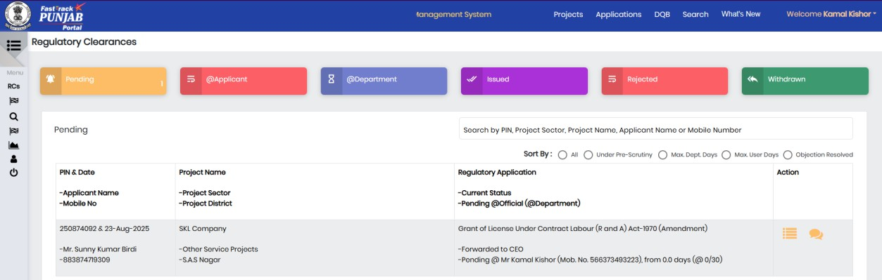
Click Here

- For processing of application, CEO needs to Click on Process button shown below:
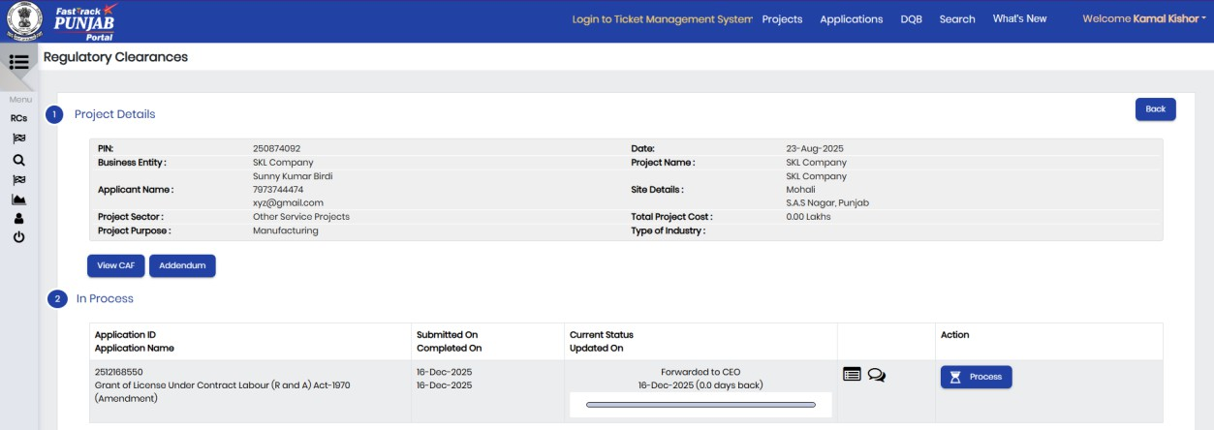
Click on Process button

- For processing, CEO will have following options:
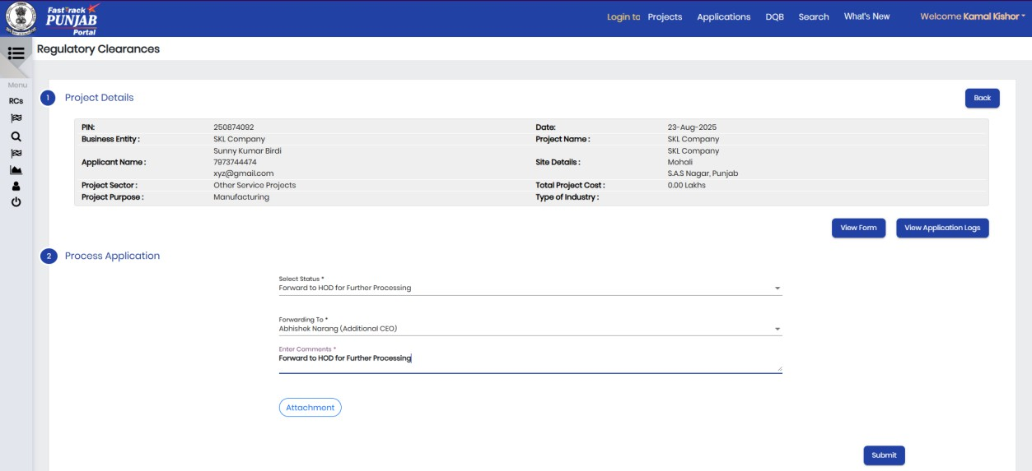
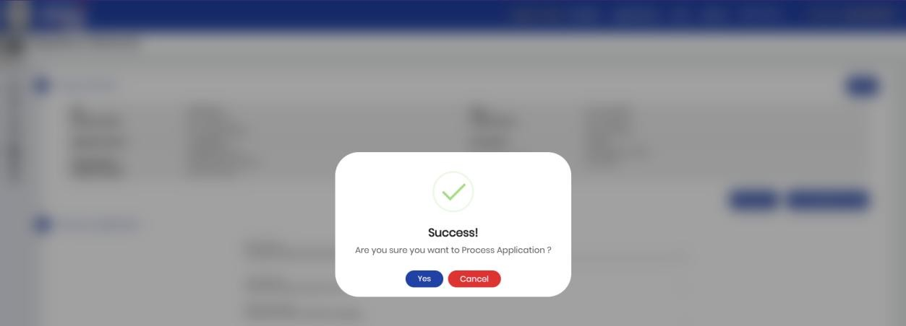
Click Here
Click Here

- The application will move to ACEO dashboard, the screen will look like as shown below:
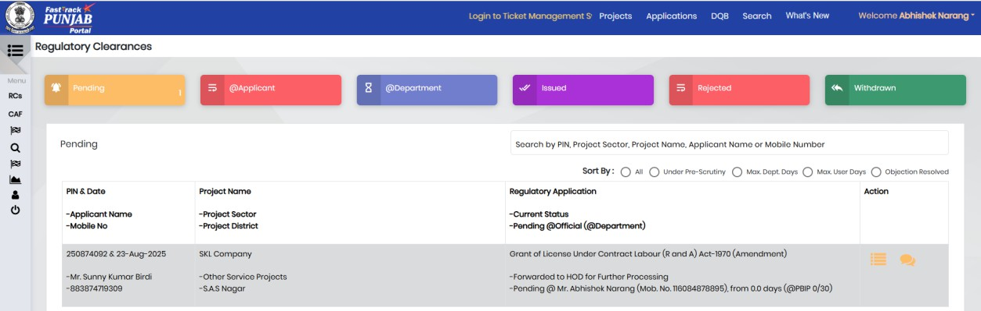
Click Here

- For processing of application, ACEO needs to Click on Process button shown below:
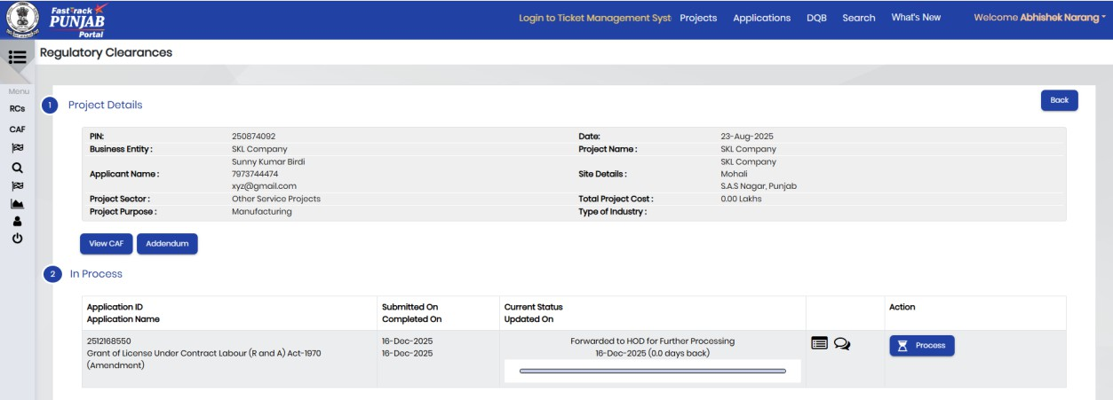
Click Here
- For processing, ACEO will have following options:
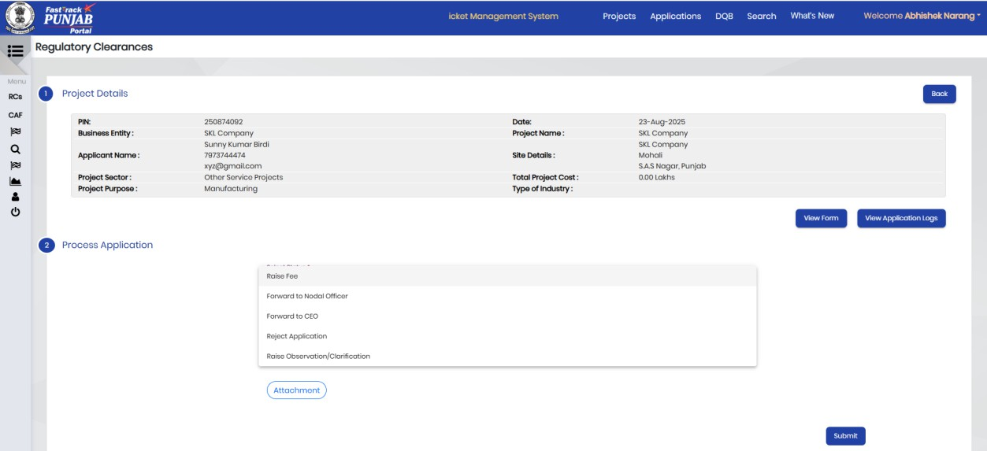
Click Here
- Here ACEO is sending application to Nodal Officer as shown below:
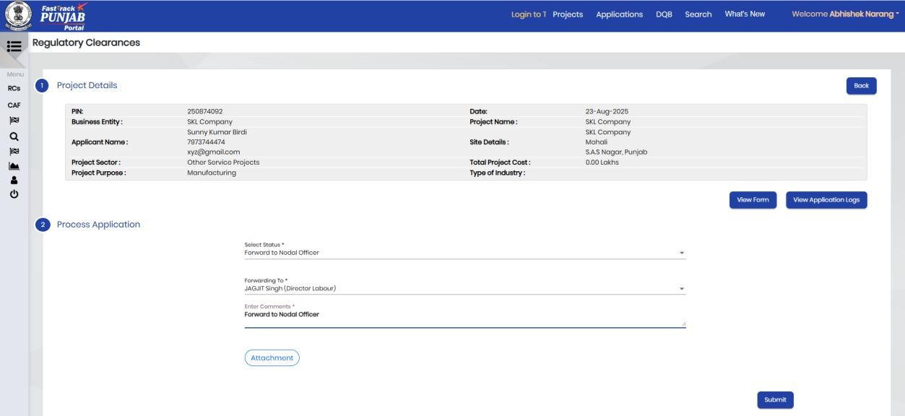
Click Here


Click Here

- The application will move to Nodal Officer dashboard, the screen will look like as shown below:
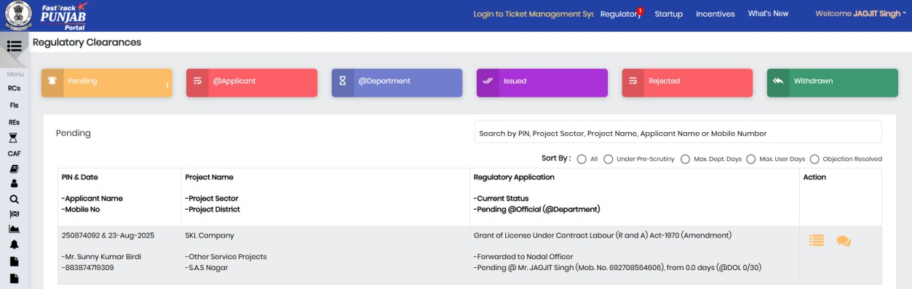
Click Here

- For processing of application, Nodal Officer needs to Click on Process button shown below:
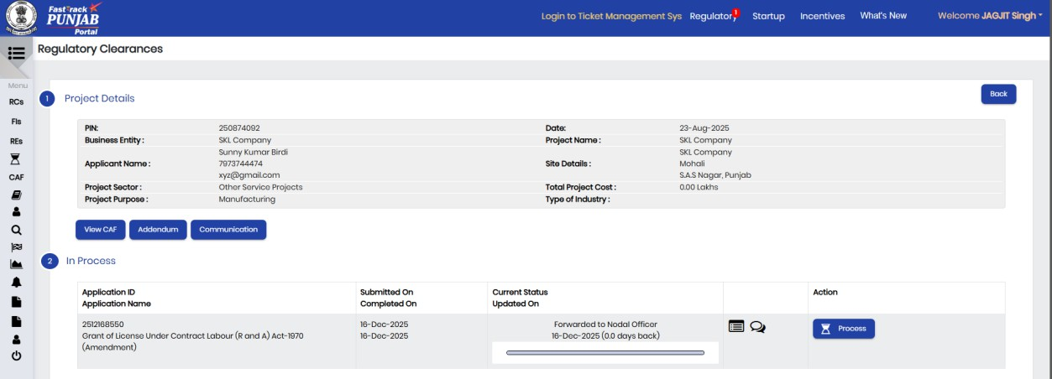
Click Here

- For processing, Nodal Officer will have following options:
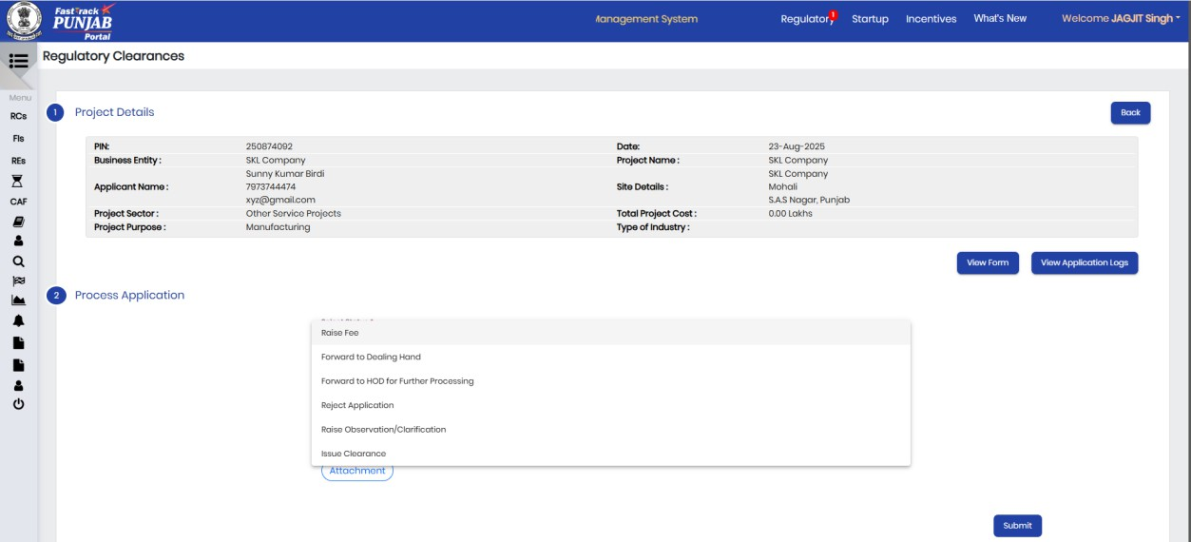
Click Here

- Nodal Officer is raising observation by clicking Raise Observation button on the screen shown below. Following screen will appear where Nodal Officer can give his/her comments:
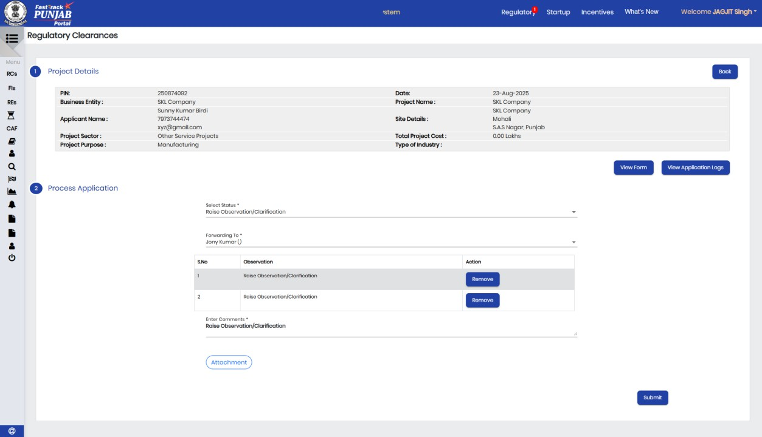
Click Here

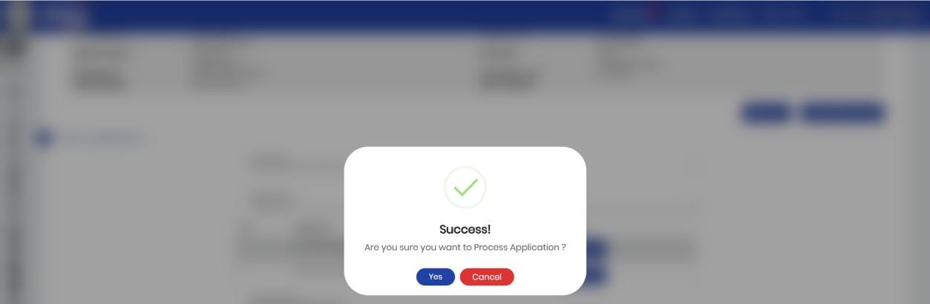
Click Here

- Once Observation raised by Nodal Officer, Application will go back to
Investor’s dashboard as shown below:
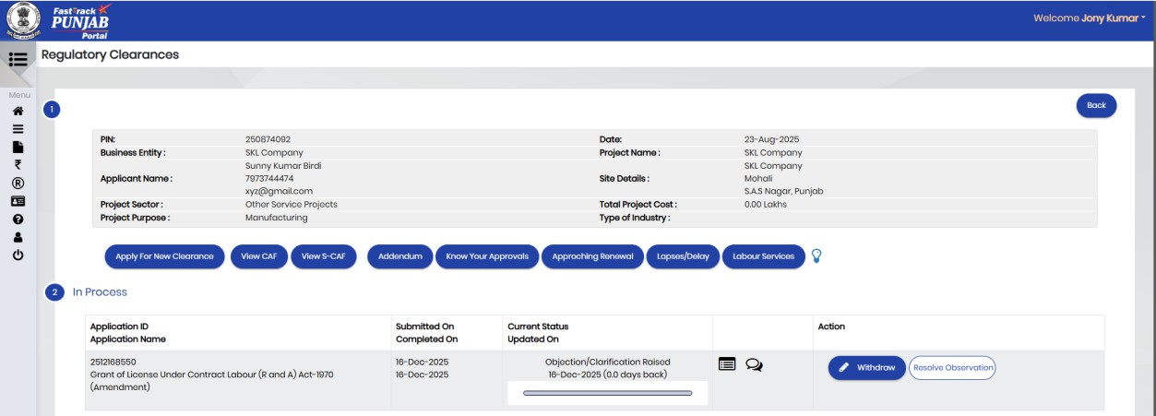
Click Here

- Investor can edit the Application Form and reply to Nodal Officer on the screen as shown below:
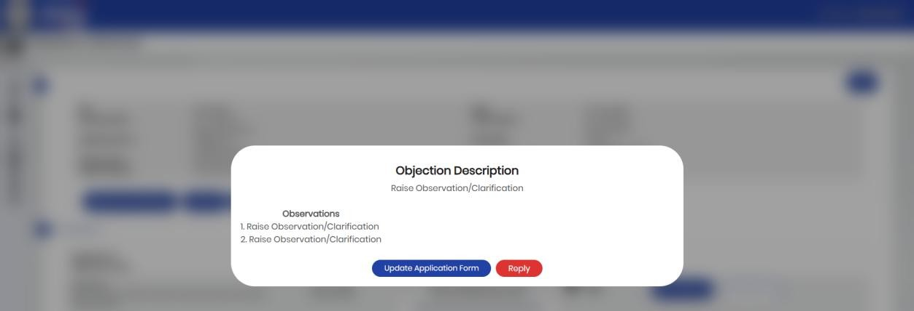
Click Here


Click here to save form

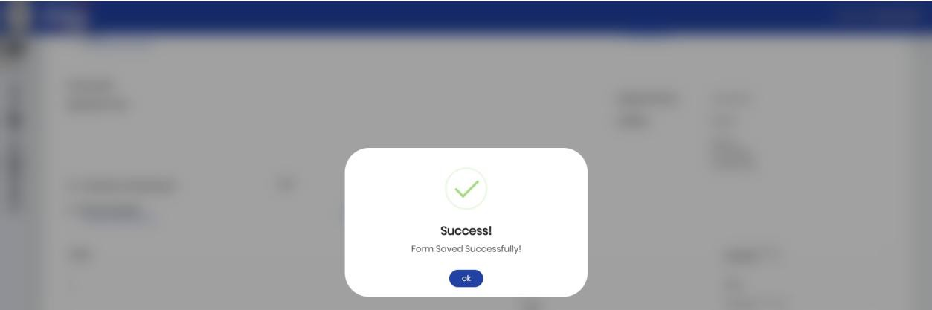
Click Yes

- After giving reply, the investor will click on Reply button on the screen as shown below:
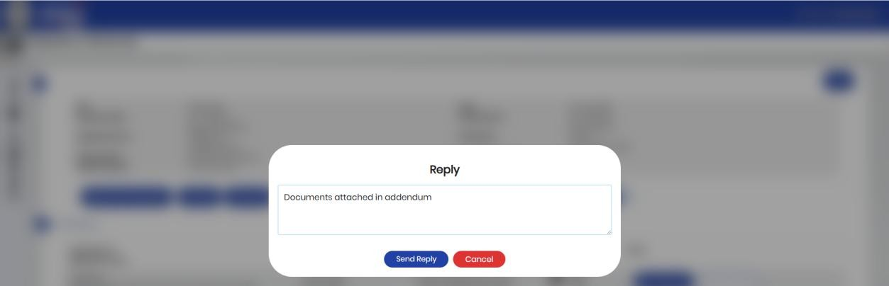
Enter comment and click on Send Reply

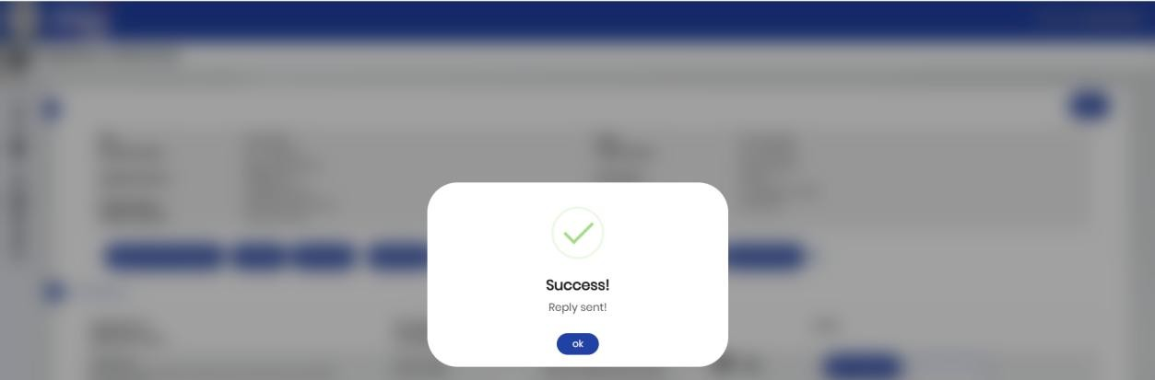
Click Yes

- The application will move to Nodal Officer dashboard, the screen will look like as shown below:
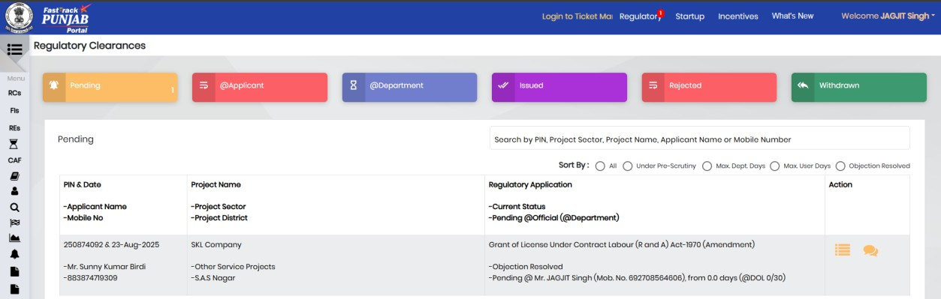
Click Here
- For processing of application, Nodal Officer needs to Click on Process button shown below:
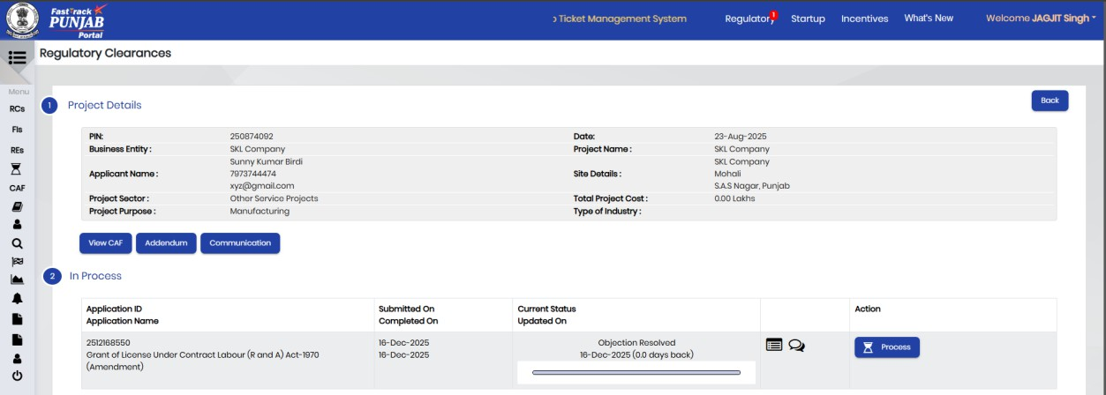
Click Process button
- For processing, Nodal Officer will have following options:
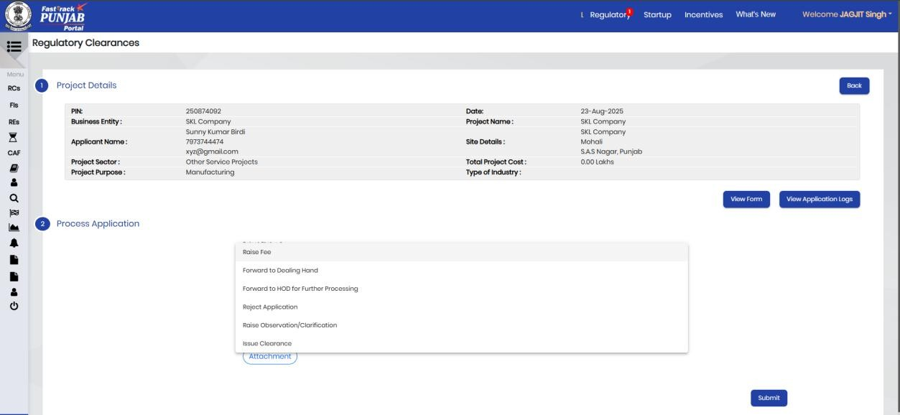
Click on Submit button

- Here Nodal Officer is Selecting Issue Clearance to Investor as shown below:
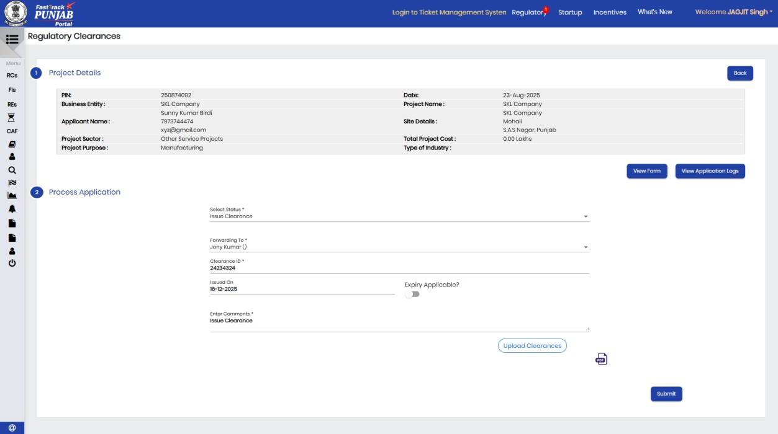
Click Here to Upload Clearances
Click Submit


Click Yes

- Investor can download Clearance from Project Details page and can give his/her feedback with rating to the services of the department. The Project Details page will look like as shown below:
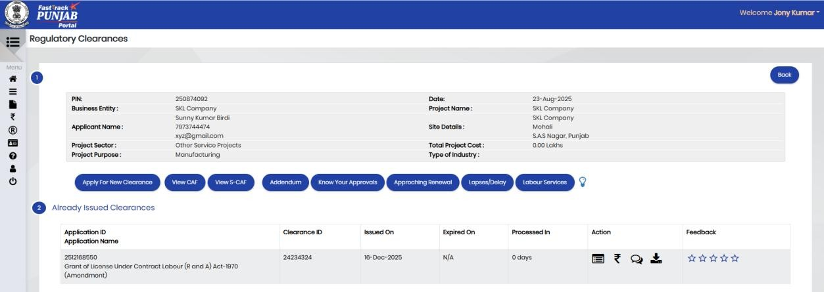
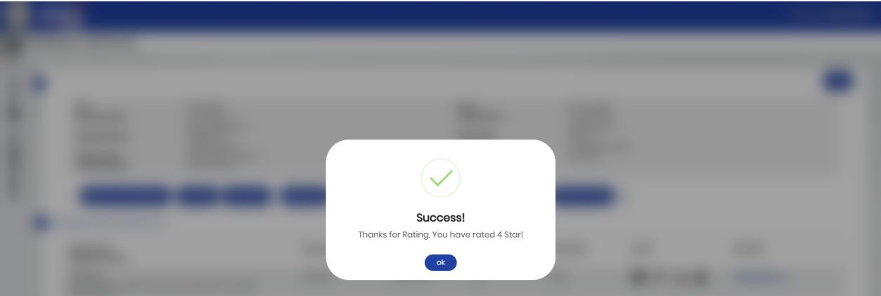
Click here for Download Clearance
Click here for Rating feedback
Click OK

- Once Investor will Click on download button then, the system will prompt the investor to enter an OTP before allowing the download of the issued clearance, as shown below:
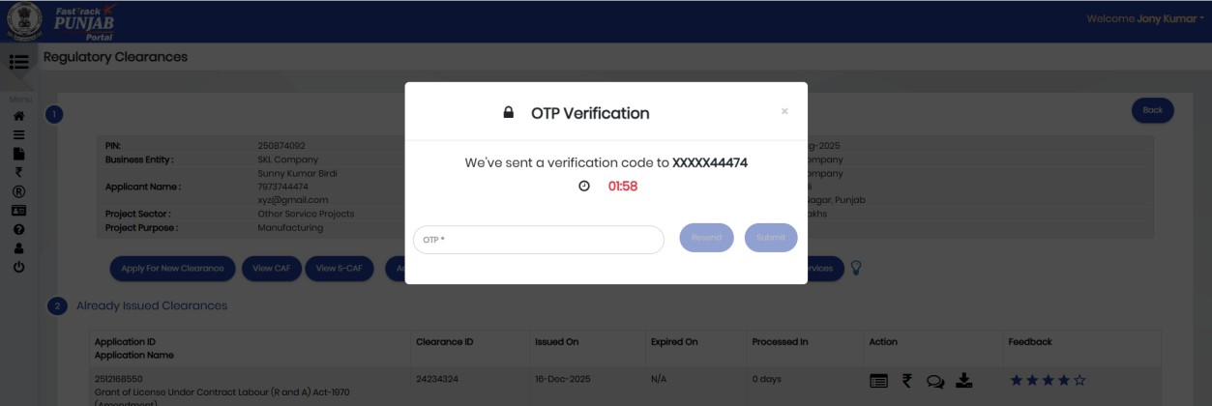

After enter the OTP, click submit button to complete the process.

